FARAWAY LANDSCAPES
Project description

IDEA
FARAWAY LANDSCAPES is a kinetic art installation exploring the impermanence of the world and oneself.
It is made of
- mechanical moving piston matrix, of size 2m by 1.5m, with addressable pistons
- a stretchable fabric connected to those moving pistons, creating a shifting 3D topology out of a 2D sheet
- a surrounding line of addressable LEDs, that can shine on the 3D topology, creating a controllable array of shadows that can move in their own time, not necessarily synchronised with a shifting 3D topology

VISUALS
- initial state 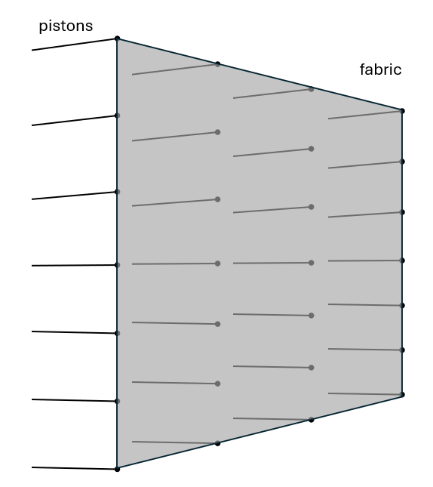
- moving pistons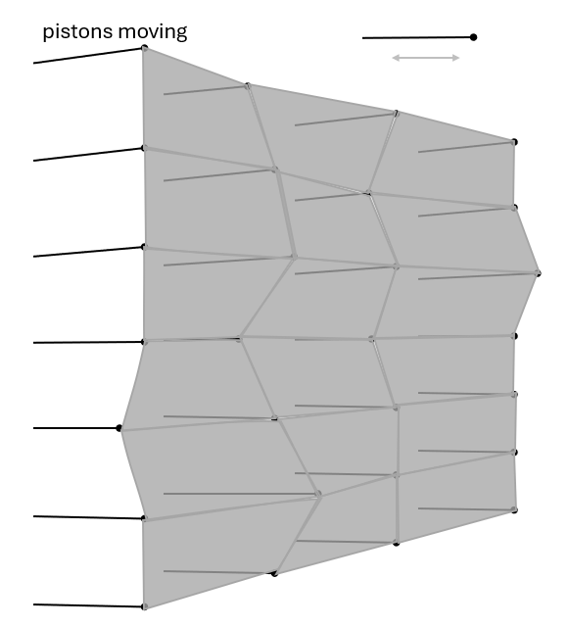
- moving LEDs and shadows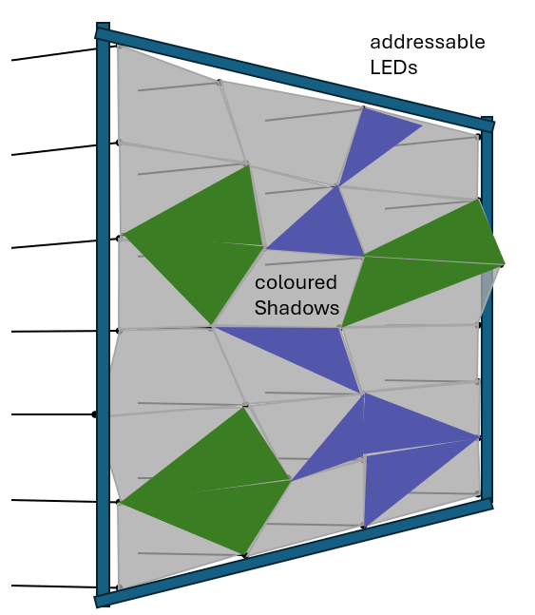

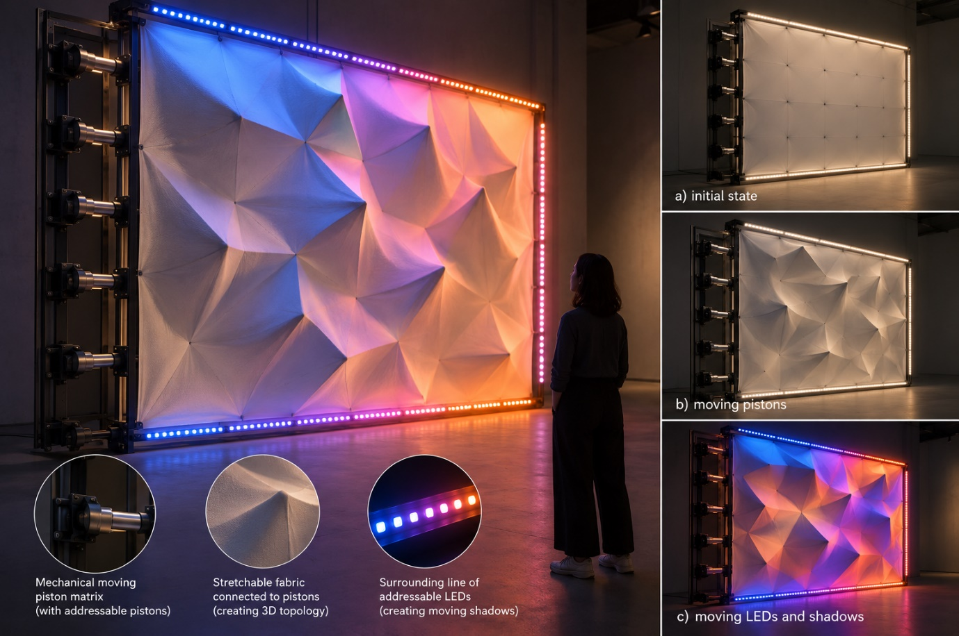

SIMULATION SOFTWARE
The simulation software should create a model of the sculpture in 3D web browser (Three.js). I should be able to:
- Setup the system: how many X, Y pistons, size of pistons, how far can they move in % of their size, amount of LEDs
- Control each piston movement
- Have a realistic movement of the fabric
- Create playable patterns of the piston movements
- Visualise the LED pattern
- Create playable patterns of LED movement
- Visualise the shadows, change the ambient light
- Rotate & zoom in into the sculpture
- Have it in the room with certain material walls, floor and ceiling
- Position a human next to it

